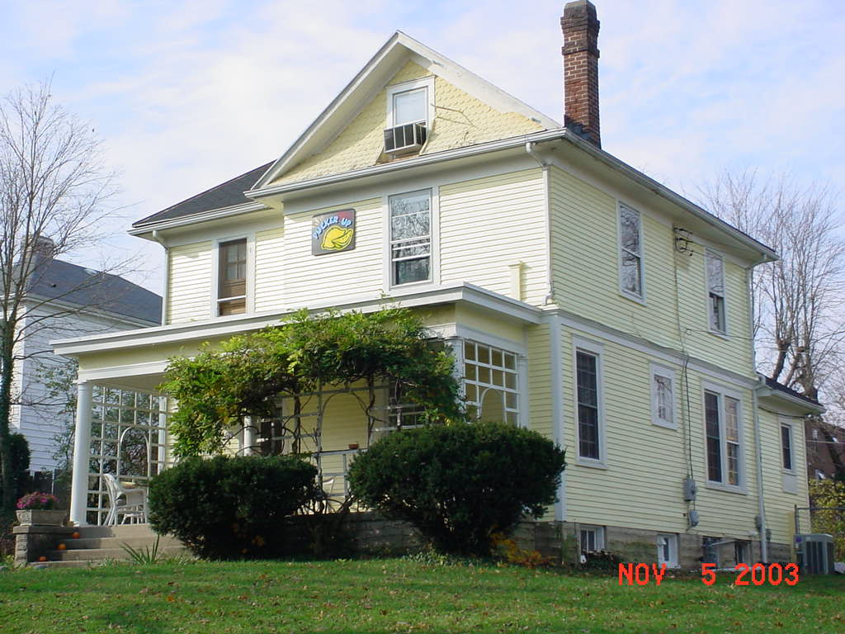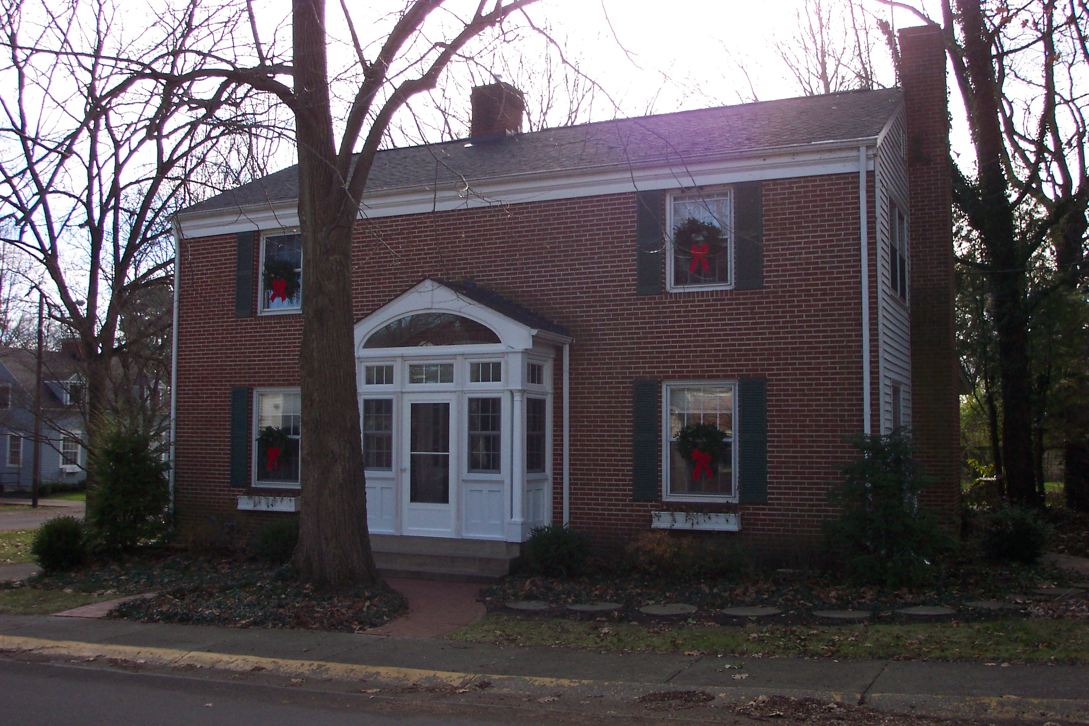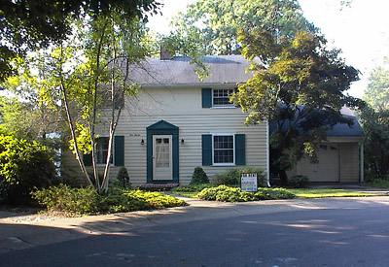
Top 10 Reasons to Live in a Home in Oxford, Ohio While at Miami University.
10. OPEN COMMUNICATION We strive to keep in constant contact with our tenants. Schmates Home Rentals maintains a website, www.schmatesrentals.com, designed to answer all of your questions from the application process to the move out after graduation.
9. RELIABLE MAINTENANCE Repairs are made as needed as opposed to a scheduled request. Emergency maintenance is available 24 hours a day.
8. CONVENIENCE All of our homes have easy access to classes, uptown, dining locations, campus events, library, sports and recreational facilities, computer labs and Miami metro bus. You are not required to move out over the holidays. Summer Storage is available.
7. MEMORABLE EXPERIENCES Variety of social, recreational, cultural activities and leadership opportunities are available at rental homes near campus. Alumni, nationwide, claim that their most memorable experiences were held at their rental homes during their college years. Some of the best lessons during the college years are learned outside the classroom!
6. HOUSEHOLD RESPONSIBILITIES- You will learn to pay rent and utility bills and manage expenses. You will learn to buy groceries, plan meals, pay rent, and even organize dinner parties! Establish a solid credit rating prior to graduation.
5. EXCEPTIONAL PERSONAL SPACE AND RECYCLING PROGRAMS Privacy, comfort and convenience! Exceptional and spacious private living areas that can be personalized by the individual. Private bathrooms, corridors, dining and family rooms. Every home also recycles in the City of Oxford.
4. PREMIER DINING OPPORTUNITES Enjoy freedom to dine when you desire given your hectic schedule. No lines and the opportunity to dine with a wide variety of healthy and tasty meals, conveniently located in your kitchen, available 24 hours a day, seven days a week. The premiere university dining plan runs $7200 for this school year. Living in a Schmates home is simply a better value than the University program.
3. THE BEST VALUE FOR THE DOLLAR- The best value verses government sponsored housing (Miami U). Lock in your living space for up to two years of “off-campus” living. No moving in & out every year. Laundry facilities in the house for your convenience. Save thousands over the states ever rising meal and housing plans. Miami University now charges in excess of $8150 a year just for a single room plus add-ons for air-conditioning and refrigerators.
2. SAFETY Oxford Police patrol 24 hours a day. Neighborhood watch programs are in place. Only you have the key to the house. No need to drive anywhere, especially in the evening since Schmates homes are within walking distance to campus and uptown.
1. ACADEMIC SUCCESS/ LEADERSHIP OPPORTUNITIES The experts agree! Recent research of college students across the nation show that students who rent homes are more prepared for the real world after their college experience, earn higher salaries, and are more likely to be successful than their on campus peers. Home rental also enhances your educational experience by providing the opportunity to be involved in a variety of aspects of household management and budgeting. Students find that with this involvement they achieve more professional growth and are stronger candidates when pursuing their career goals.
Reserve your home for next year now at www.schmatesrentals.com or email us info@schmatesrentals.com

