Dear Miami Parents:

“We laughed when you told us we’d never want to leave. We cried when you told us we had to.”

Your young adult is embarking on an exciting new chapter of their life. The tradition of living in a home at Miami is not to be missed. They will look back at this moment as a milestone in time. Let’s agree, from the backyard barbecues to the Sunday night dinners your young adult’s four years at Miami will be some of their fondest memories ever! Living in a Schmates home is different than an apartment, with no windows, parking or backyard, or a state-run dorm. During the first few weeks of school, students are required to choose on or off campus housing for the next school year. By junior year all students are ready to move off campus. They are choosing to live off-campus so they can learn the real-world skills of running and managing a household. This allows them to concentrate on academics in a comfortable, safe, sanitary and purposeful learning environment as opposed to the overcrowded conditions of a dorm.

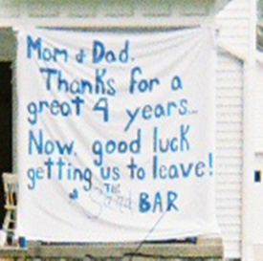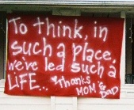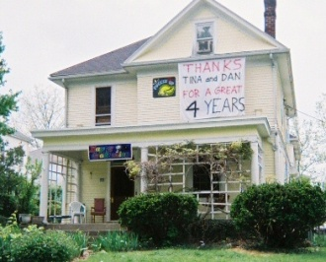
As a state run institution, Miami University utilizes pricing guidelines for their housing that do not apply to the private sector. The benefits of living in a Schmates Home include:
- Move into your home early before the rest of the students. The university provides just a short window of time for students to move into the dorms at the beginning of the school year and before and after holidays. Remember freshman year, 12,000 people trying to move in the dorm on the same day in the sweltering Oxford humidity in August while driving rental truck with no AC?
- Your young adults can eat healthy for a lot less. They can get experience preparing meals for themselves, and enjoy Sunday suppers with college friends in their own dining room. Miami’s premiere meal plan will cost $3656 plus per semester or $7312 for the 2022-23 school year, plus care packages and late-night pizzas. By going to the grocery, they will never spend $7000 a year in meals. Living off campus, our students spend an average of $1500 per semester/$3000 year. This is a savings of about $4000 a year.
- Avoid additional charges. In addition to the basic dorm room charges, students can also be charged for such add-on items as A/C ($300) & parking ($425 semester/$850 yr.). Coin-op laundry charges ($3.50 load & $1.75 dry) for four averages over $1100 yr. The dorm rooms have a very small square footage of living space (avg. 150 sq. ft. for two). Compare that to our single bedrooms which average 125 sq. ft. Plus, they have use of the rest of the home! In addition, the cost to stay in the dorm during J term is $40 a day per person x 21 days x 4 people= $3360. These savings alone total in excess of $2000 per person!
- The housing portion to live in a one bedroom university apartment will be $6214 per semester or $12,428 per year for the 2022-23 school year. The cost for a double-occupancy room with a roommate will be $5266 per semester or $10,532 a year. The cost to live in a Heritage Commons single room will be $6414 per semester or $12,828 per year. We can provide a better experience and value in a Schmates Home for a portion of this amount. Our students average saving over $7000-8000 a year in housing & meals compared to living on campus

As the housing selection process approaches, students and parents can visit as well as receive information on each of the Schmates homes. Our website describes the details of the leasing process and includes a sample lease. Please email us at info@schmatesrentals.com or visit our website at www.schmatesrentals.com. You will be able to view the homes by clicking on their home selection. We trust that this information will answer your questions and concerns.

Remember that the selection process for the homes begins early, and the best locations are the first to be selected. Students who have selected housemates come together with a completed application and signed lease as well as the full security deposit for the selected home. The signed lease is then scanned and e-mailed to Schmates Home Rentals. After application reviews are conducted the contract becomes legally binding. Copies are made and emailed to the lessees.

We strive to ensure that your young adult has a home that promotes a healthy progressive learning environment. He or she will gain life-long friendships, memories, and the skill set of running a household. We will assist your student and housemates through one of the most professional residential property management teams in the country. We are proud to be able to handle special requests from students in a timely and efficient manner.

We at Schmates Home Rentals are Miami University graduates and mergers as are our children. In fact 18 family members representing 3 generations have gone to Miami! We understand and respect the small town atmosphere of Oxford. All of our homes are well maintained, landscaped and secure. Great pride is taken in their upkeep, and we work hard to improve them each year. Please look over and review our website www.schmatesrentals.com for the features that off-campus living has to offer for your young adult. As parents we know some of the best lessons during your college years are learned outside the classroom

The credit hours required to graduate will soon be forgotten. The number of memories in their Schmates home will live forever! Your young adult will have a host of cherished Miami stories tucked in their minds and hearts from their two short years living in a home at Miami. Make the experience a memorable one in a Schmates Home. We look forward to seeing your students in one of our homes next year. Please contact us at info@schmatesrentals.com with any questions or concerns that you may have.

Best regards,
Schmates Home Rentals, LLC

